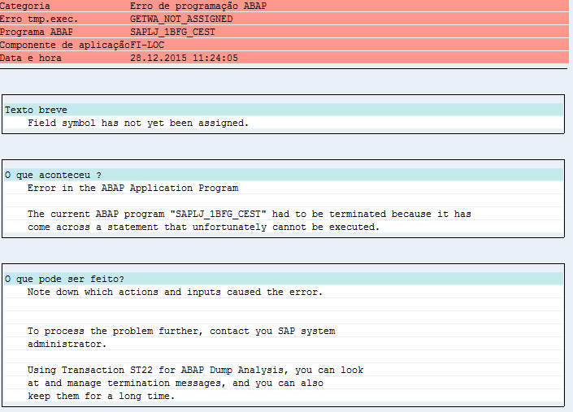
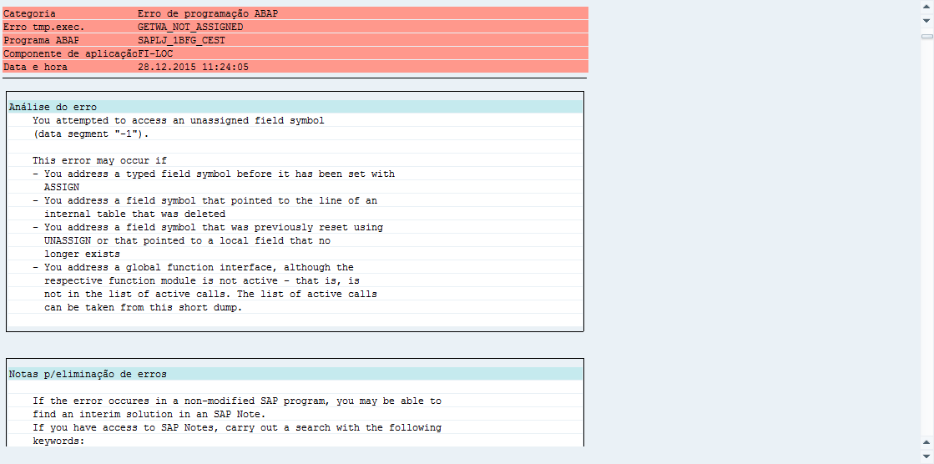

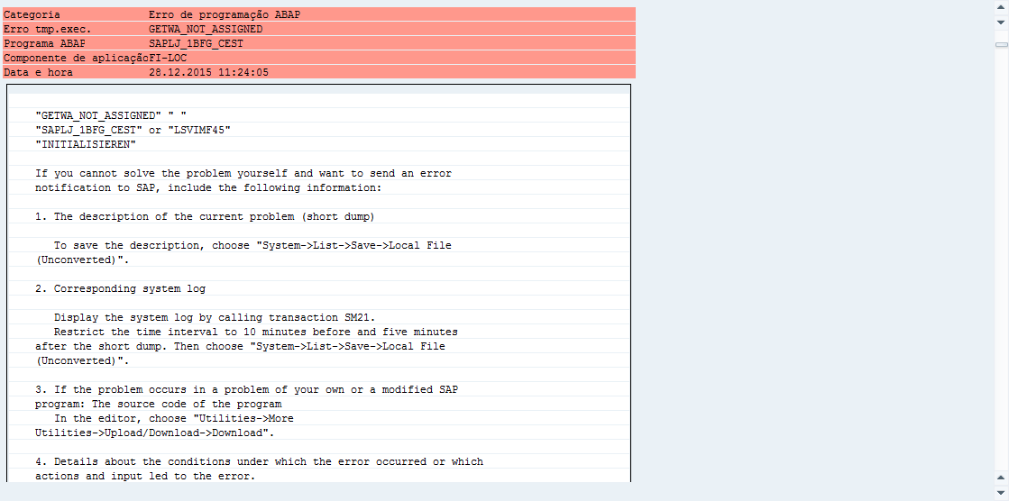

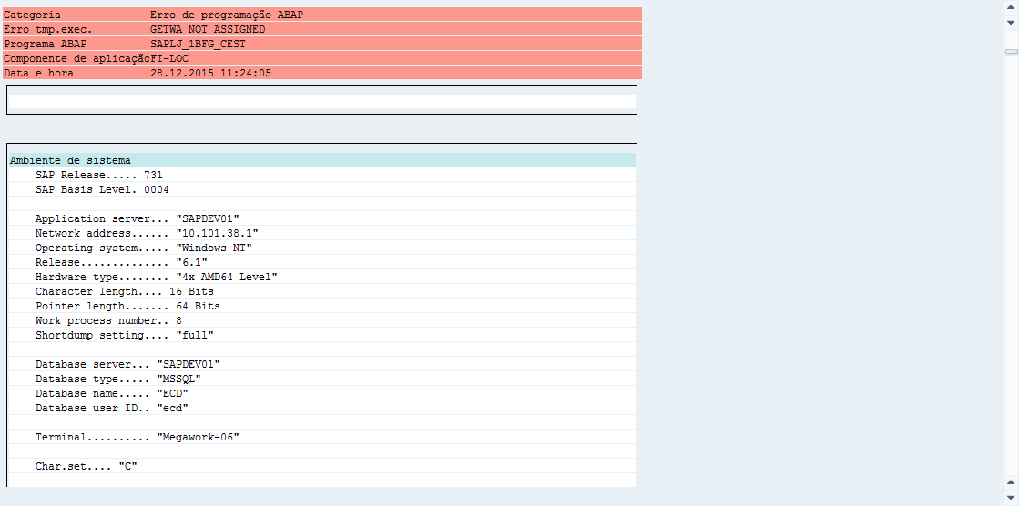

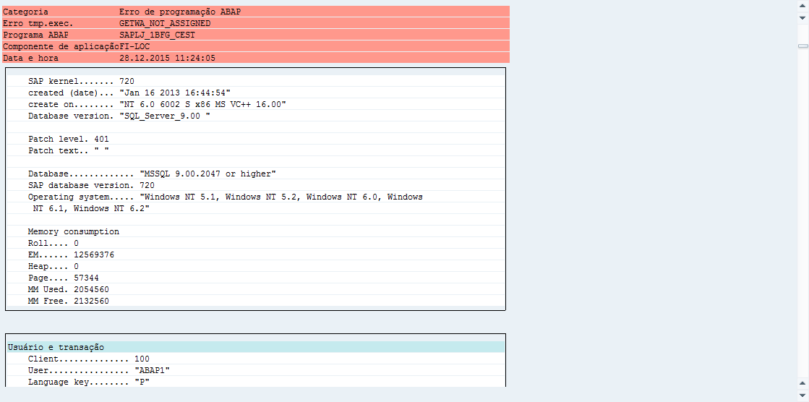
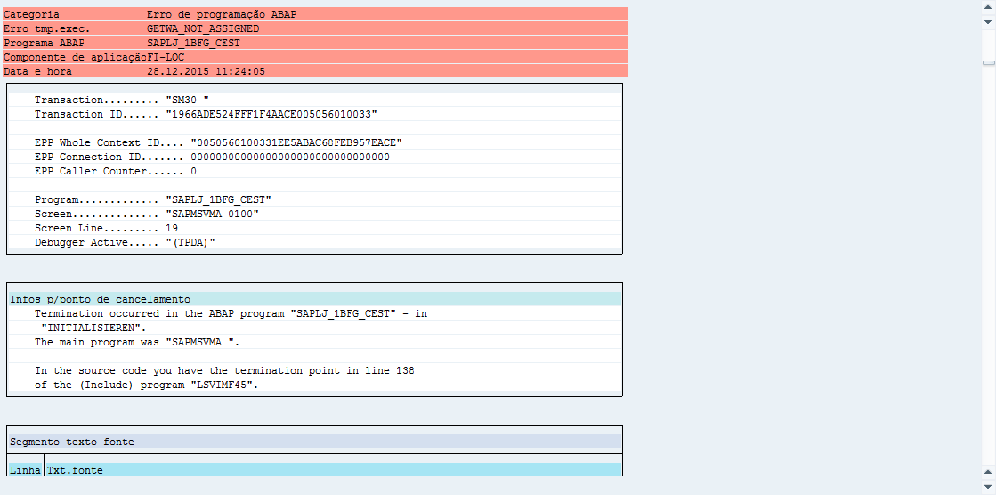

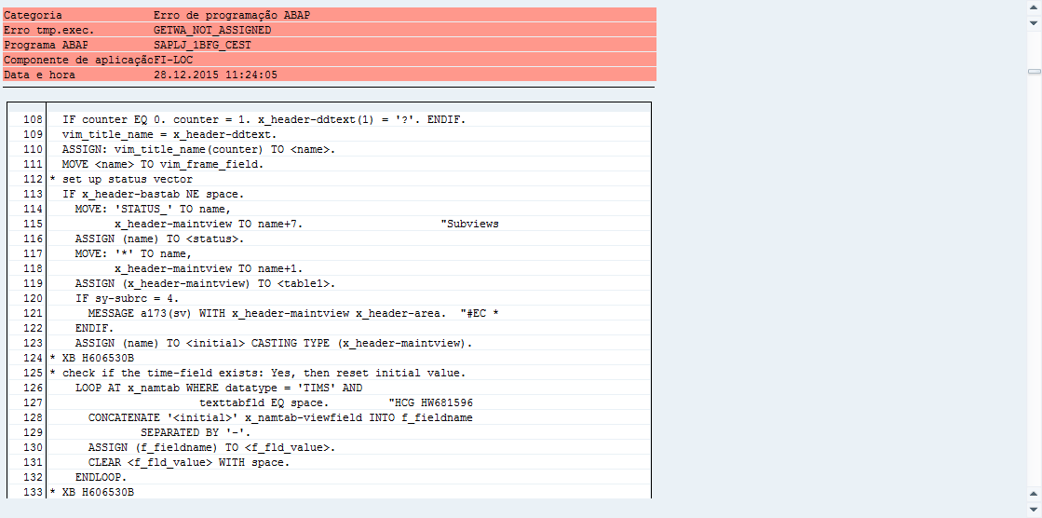

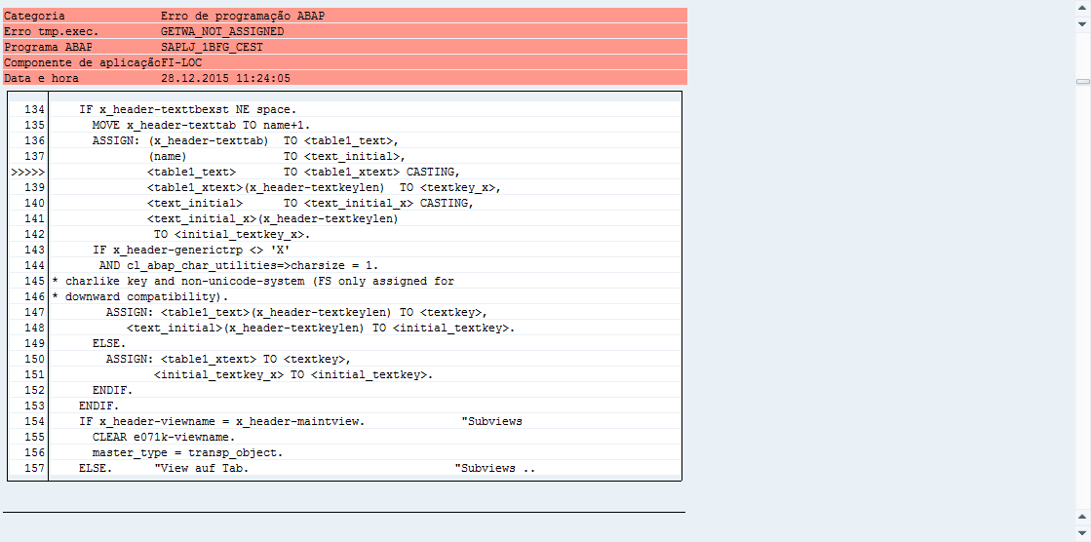
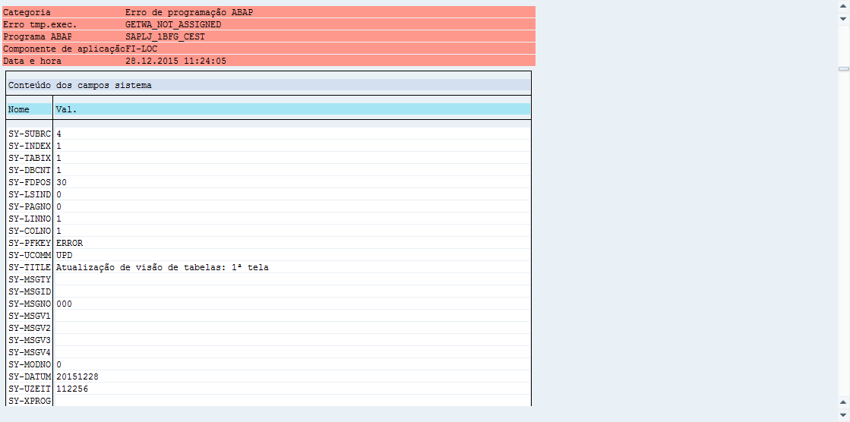

<textkey_x> EQ <initial_textkey_x>
SAPLJ_1BFG_CEST

J_1BFG_CEST

SAPLJ_1BFG_CEST / LSVIMF45
FORM / INITIALISIEREN

X_HEADER-TEXTTBEXST

SAPLSVIM / LSVIMU03
FUNCTION / VIEW_MAINTENANCE_CALL

VIEW_GET_DDIC_INFO => header = x_header
stat_tab
VIEW_GET_DDIC_INFO

SAPLSVIX / LSVIXF01
FORM / READ_DDIC => 201
SELECT tabname fieldname FROM dd08l INTO TABLE dd08l_tab
WHERE checktable = rd_tabname
AND as4local = 'A'
AND frkart = 'TEXT'.

SAPLSVIX / LSVIXF01
FORM / READ_DDIC => 146

Tinha colocado o campo chave da tabela A (J_1BTCEST) como foreing key da tabela B e C. (Sendo que as duas eram iguais - J_1BCESTT / J_1BTCESTT)

SELECT tabname fieldname FROM dd08l INTO TABLE dd08l_tab
WHERE checktable = rd_tabname
AND as4local = 'A'
AND frkart = 'TEXT'.
CLEAR: text_tab_exists, text_table_name, langufield.
DESCRIBE TABLE dd08l_tab.
rc_loc = 4.
IF tvdir-bastab = space AND 'CV' CS w_dd25v-viewclass.
* exactly one text table used in view?
CLEAR w_dd08l.
CLEAR it_texttabnames.
LOOP AT dd08l_tab ASSIGNING <w_dd08l>.
READ TABLE dd27p_tab "View(variant)
WITH KEY tabname = <w_dd08l>-tabname TRANSPORTING NO FIELDS.
IF sy-subrc = 0 OR viewvari_of_tab = 'X'.
IF w_dd08l-tabname IS INITIAL.
w_dd08l = <w_dd08l>.
CLEAR rc_loc.
ELSE.
CLEAR texttabagain.
LOOP AT it_texttabnames INTO wa_texttabname.
IF wa_texttabname = <w_dd08l>-tabname.
texttabagain = 'X'. "Same text table again
ENDIF.
ENDLOOP.
IF texttabagain = ' '.
rc_loc = 4.
EXIT.
ENDIF.
ENDIF.
COLLECT w_dd08l-tabname INTO it_texttabnames.
ENDIF.
ENDLOOP.
ELSEIF sy-tfill = 1.
* table: only one text table supported
READ TABLE dd08l_tab INTO w_dd08l INDEX 1.
* text table exists:
CLEAR rc_loc.
ELSEIF sy-tfill > 1. " BX 06092002 BCEK063349
* table: more than one text tables
LOOP AT dd08l_tab INTO w_dd08l.
* check if they are the same.
AT NEW tabname.
p_txttab_sum = p_txttab_sum + 1.
ENDAT.
ENDLOOP.
IF p_txttab_sum = 1.
* text tables are the same. text table exists.
CLEAR rc_loc.
ELSE.
CLEAR w_dd08l.
ENDIF.
ENDIF. "sy-tfill = 1

